1. **INTRODUCTION**
2. **OVERVIEW**

**The Toxic Classifier Flask App classifies the comment entered into different types of toxicity and shows the probability of how toxic the comment made is.**

1. **PURPOSE**

**The Social Media could be a medium to spread hate, abuse and toxicity. The toxic classification flask app helps us know if the comment made is toxic or not.**

**The App could create a better and friendlier environment in social media**

1. **LITERATURE SURVEY**

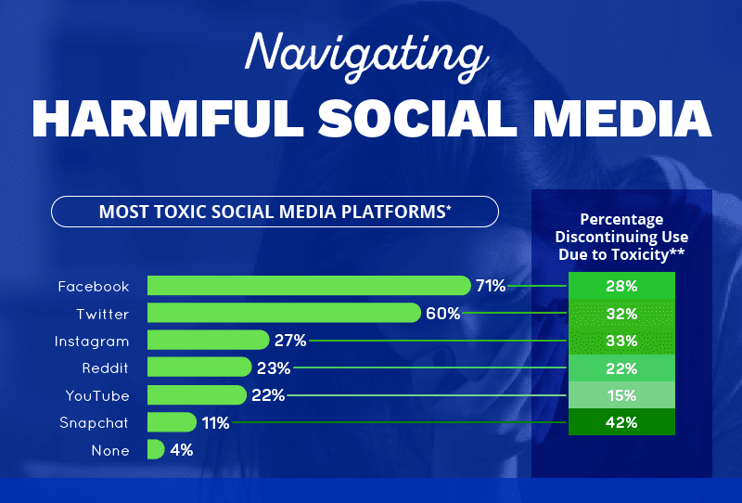

1. **EXISTING PROBLEM**

**Various studies have shown that a high use of social media increases the likelihood of people feeling anxious, depressed, or lonely. It has even been shown to increase the risk of self-harm and suicide.**

1. **PROPOSED SOLUTION**

**The Toxic Classifier Flask App’s Algorithm could be integrated into social media platforms comment section, letting the user know about the comment they are making toxic or not.**

**The Social Media Platforms could also verify the comments made are toxic or not when such comments are reported.**

1. **THEORETICAL ANALYSIS**
2. **BLOCK DIAGRAM**

1. **HARDWARE / SOFTWARE DESIGNING**

**The Major Libraries which have to be installed for running this project are :**

* scikit-learn
* re
* numpy
* pandas
* scikit-multilearn
* keras
* tensorflow
* matplotlib
* nltk
* string
* seaborn
* Preprocessing

1. **EXPERIMENTAL INVESTIGATIONS**

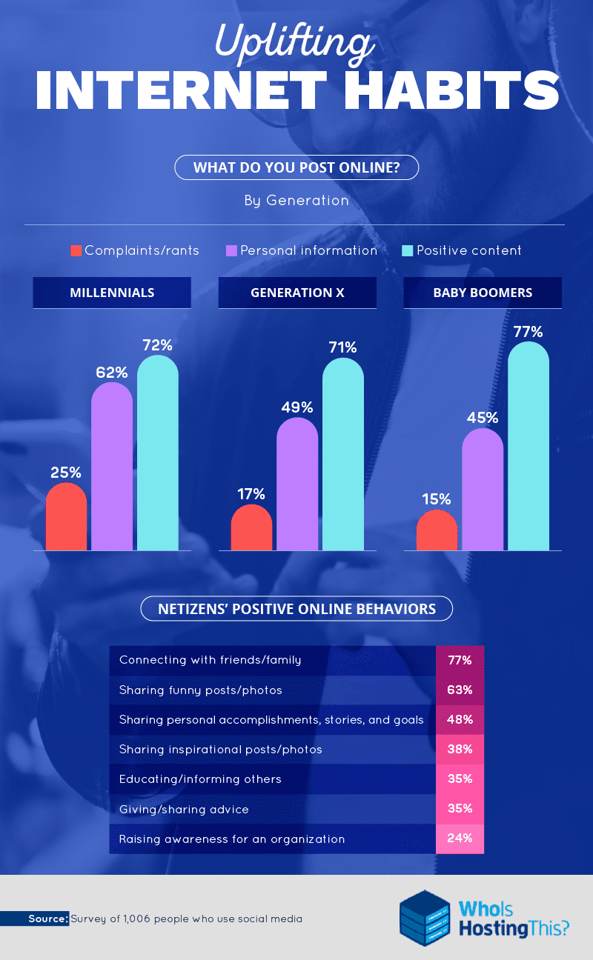

1. **FLOWCHART**

1. **RESULT**

1. **ADVANTAGES & DISADVANTAGES**

**The App could sort & differentiate between toxic and non toxic comments.**

**It could help create a better and friendlier environment in social media companies.**

**The algorithm could also be fooled by certain people using different tricks to spread hate, abuse and toxicity.**

**Hence, the database needs to be updated with these new toxic comments as well.**

1. **APPLICATIONS**

**The comments that are reported by the user as hate, insult, toxic, etc could be verified by the algorithm and take necessary action to remove such comments from social media to make it a friendly and constructive environment.**

1. **CONCLUSION**

**The number of users on social media is increasing daily to new records, along with this their is a risk of more people spreading hate, abuse and toxicity on the platforms. More people could be influenced by such toxicity... so we could automate the system to identify toxic comments and remove them.**

**Doing it with great speeds and in an efficient manner.**

**10. FUTURE SCOPE**

**Improvised and better data sets could be used to create even more efficient predicting systems, they could also be integrating within the comment section of the social media platforms.**

**This will help reduce the toxicity in the social media and create a much better user experience.**

**11. BIBLIOGRAPHY**

1. <https://www.kaggle.com/c/jigsaw-toxic-comment-classification-challenge>
2. [(PDF) Challenges for Toxic Comment Classification: An In-Depth Error Analysis (researchgate.net)](https://www.researchgate.net/publication/327345300_Challenges_for_Toxic_Comment_Classification_An_In-Depth_Error_Analysis)
3. [Toxic Comment Classification - Natural Language Processing - Jay Speidell](https://jayspeidell.github.io/portfolio/project05-toxic-comments/)
4. [Classifying Toxicity in Online Comment forums: End-to-End Project | by Luke Newman | Towards Data Science](https://towardsdatascience.com/classifying-toxicity-in-online-comment-forums-end-to-end-project-57720af39d0b)

**12. APPENDIX**

**a. SOURCE CODE**

**PLEASE REFER TO THE BELOW LINK:**

<https://github.com/smartinternz02/SI-GuidedProject-5373-1630315471>

**b. UI OUTPUT SCREENSHOT**

